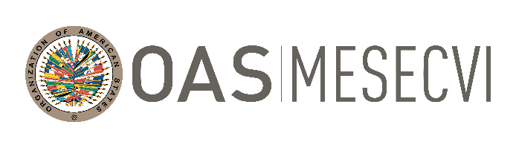

FOLLOW-UP MECHANISM OAS /Ser.L/II.7.10
BELÉM DO PARÁ CONVENTION (MESECVI) MESECVI/CEVI/264/21.corr1
Eighteenth Meeting of the Committee of Experts 7 December 2021
7 and 8 December 2021 Original: Spanish
Virtual Platform: Zoom

ORGANIZATION OF WORK

Date: December 7 and 8, 2021
Time: 09:00 - 13:00
Platform: Zoom

Tuesday, December 7th

09:00 to 09:15 Inauguration
- Alejandra Mora Mora, Executive Secretary, Inter-American Commission of Women (CIM)
- Nadine Gasman, President of the National Women's Institute of Mexico and Chair of the Conference of States Parties (CEP)
- Tatiana Rein Venegas, Chair of the Committee of Experts of MESECVI (CEVI)

09:15 to 09:20 Official photograph

09:20 to 09:45 Approval of the Annual Activity Report of the Committee of
Experts of the MESECVI
Debate

09:45 to 10:45 Report on Child Marriage and Early Unions
Debate

10:45 to 11:45 Recommendation No. 3 on the concept of consent in cases of gender-based sexual violence
Debate

11:45 to 12:45 Follow-up on the actions taken by the States Parties to the Belém do Pará Convention to Prevent, Punish and Eradicate Violence Against Women and girls within the framework of COVID-19 and its consideration as an emerging issue
Debate

Wednesday, December 8

09:00 to 10:00 Presentation of the Working Group and the Strategy for the English-speaking Caribbean Countries
- Indicators for the Fourth Multilateral Evaluation Round
- Strengthening of relationship with English-speaking Caribbean Countries
- Definition of needs
- Emerging issues:
Obstetric violence
Climate change and violence
Impact of COVID19
- Fundraising
Debate

10:00 to 10:20 Special projects and strategic alliances of MESECVI
United Nations, European Union, Instituto Belisario Domínguez
Exchange

10:20 to 11:00 Follow-up to the Fourth Multilateral Evaluation Round
- Diagnostic Reports in the framework of the Fourth Multilateral Evaluation Round
- Assigning of working subgroups to produce National Reports
- Integrated System of Automated Indicators

11:00 to 11:15 Communication strategies and new technological tools

11:15 to 11:45 Election of new authorities of the Committee of Experts

11:45 - 12:30 Adoption of agreements

12:30 to 12:45 Other business

12:45 to 13:00 Closing

